 | 
Laboratory 5: Creating a Smart Home Dashboard in Home Assistant (Lovelace UI) | School of Applied Digital Technology
Name:  Name: | ID:  ID: | Section:  Section:
Date: | Due date:
Objectives
- Learn how to design a Lovelace Dashboard to visualize real-time sensor data.
- Understand how to use various Lovelace cards such as Entities, Graph, Gauge, and Button.
- Practice integrating data from sensors and actuators to build an interactive Smart Home UI.

Equipment and Software
Item | Description
💻 Computer | Running Docker
🏠 Home Assistant (Container) | Core system for Smart Home dashboard
📡 ESP32 / ESP8266 | Microcontroller board for sensor data
🌡️ DHT11 / DHT22 | Temperature and humidity sensor
💨 MQ-2 Gas Sensor | Detects smoke and gas
💡 LDR Sensor | Measures light intensity
🚶 PIR Motion Sensor (HC-SR501) | Detects motion
🔔 Buzzer / 💨 Fan / 💡 LED | Actuators controlled via GPIO or relay

Enable YAML Mode for Lovelace Dashboard

Edit the file configuration.yaml in your /config/ directory and add:
Yaml :
lovelace:
mode: yaml
resources:
- url: /hacsfiles/lovelace-card-mod/card-mod.js
type: module
dashboards:
smart-home-dashboard:
mode: yaml
title: "Smart Home Dashboard"
filename: lovelace-dashboard.yaml
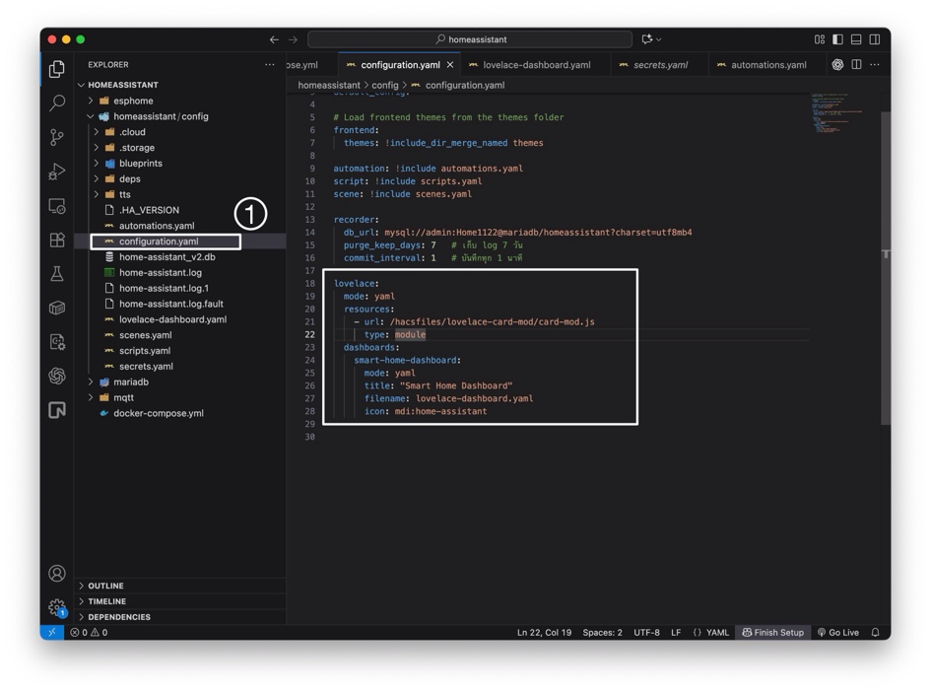
icon: mdi:home-assistant
💡 Note:
- Restart Home Assistant after editing.
- The dashboard file lovelace-dashboard.yaml will be created and stored in /config/.
- The dashboard name must contain a hyphen (-) instead of an underscore (_).
Example: ✅ smart-home-dashboard
❌ smart_home_dashboard
- After saving, go to
Settings → Developer Tools → YAML → Check Configuration and then click Restart if no errors appear.
- Create the Dashboard File
- Create a new file named lovelace-dashboard.yaml in the /config/ directory.
- Paste the code below:
Yaml:
title: "🏠 Smart Home Dashboard"
views:
- title: "Living Room"
icon: mdi:sofa
cards:
# --- Sensor Data ---
- type: entities
title: "📋 Sensor Data"
entities:
- entity: sensor.living_room_temperature
name: "🌡️ Temperature"
- entity: sensor.living_room_humidity
name: "💧 Humidity"
- entity: sensor.mq_2_gas_level
name: "💨 Gas Level"
- entity: sensor.ldr_light_level
name: "💡 Light Level"
- entity: binary_sensor.living_room_motion
name: "🚶 Motion Detected"
- entity: binary_sensor.gas_alarm_active
name:"⚠️ Gas Alarm"

# --- Historical Graphs ---
- type: history-graph
title: "📈 Environment Trends"
hours_to_show: 12
refresh_interval: 30
entities:
- entity: sensor.living_room_temperature
- entity: sensor.living_room_humidity
- entity: sensor.mq_2_gas_level

# --- Temperature Gauge ---
- type: gauge
entity: sensor.living_room_temperature
name: "🌡️ Temperature °C"
min: 0
max: 50
severity:
green: 0
yellow: 30
red: 40
# --- Light Level Gauge ---
- type: gauge
entity: sensor.ldr_light_level
name: "💡 Light Level (V)"
min: 0
max: 3.3
severity:
red: 0.5
yellow: 1.0
green: 2.0

# --- Device Controls ---
- type: grid
title: "🔧 Device Controls"
columns: 3
cards:
- type: button
entity: fan.living_room_fan
name: "Fan"
icon: mdi:fan
tap_action: { action: toggle }
- type: button
entity: switch.active_buzzer
name: "Buzzer"
icon: mdi:volume-high
tap_action: { action: toggle }
- type: button
entity: switch.indicator_led
name: "LED"
icon: mdi:led-on
tap_action: { action: toggle }

# --- Map (for Lab 9) ---
- type: map
title: "📍 Sensor Location"
default_zoom: 15
entities:
- entity: sensor.living_room_temperature
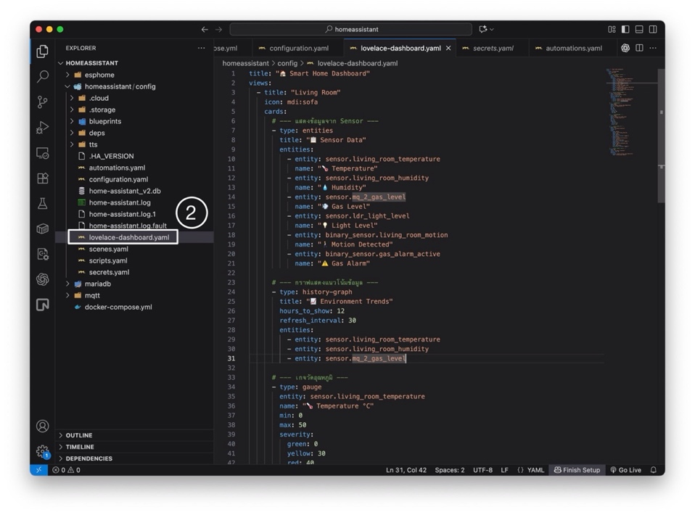
name: "Living Room Sensor"

- Add Automations for Device Control
- Edit /config/automations.yaml and add:
Yaml:
# Turn on the fan when temperature exceeds 30°C
- alias: "Auto Fan Control"
trigger:
- platform: numeric_state
entity_id: sensor.living_room_temperature
above: 30
action:
- service: fan.turn_on
entity_id: fan.living_room_fan

# Turn on buzzer and LED when gas is detected
- alias: "Gas Warning Alert"
trigger:
- platform: state
entity_id: binary_sensor.gas_alarm_active
to: "on"
action:
- service: switch.turn_on
entity_id: switch.active_buzzer
- service: switch.turn_on
entity_id: switch.indicator_led
- service: persistent_notification.create
data:
title: "Gas Alert 🚨"
message: "⚠️ Gas or smoke detected in the room!"

# Automatically turn on the light when motion detected in darkness
- alias: "Auto Light When Motion"
trigger:
- platform: state
entity_id: binary_sensor.living_room_motion
to: "on"
condition:
- condition: numeric_state
entity_id: sensor.ldr_light_level
below: 0.7
action:
- service: light.turn_on
entity_id: light.room_light
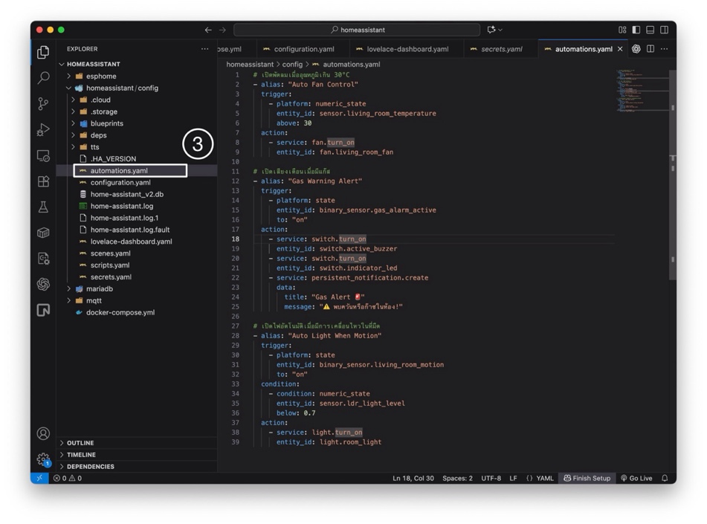

- View the Dashboard
Open:
👉 http://localhost:8123/lovelace/smart-home-dashboard
You should see a clean, interactive dashboard containing:
• Real-time sensor readings
• Graphs and gauges
• Control buttons for fan, buzzer, and LED
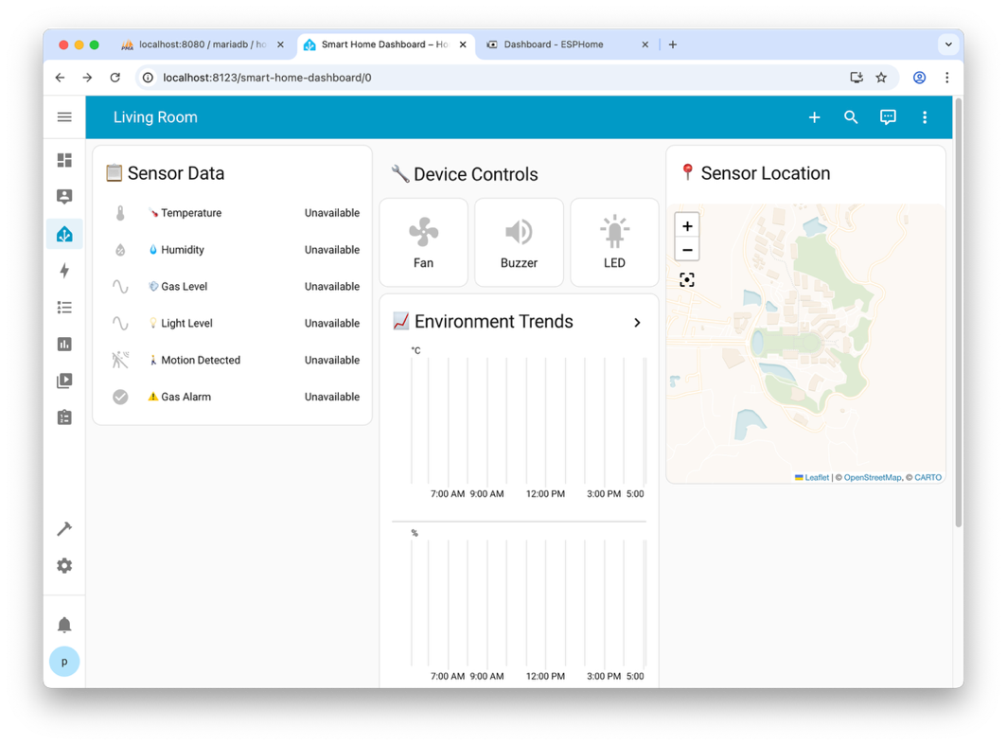
• A map card (for use in Lab 9)

Take 1: Organize and Add a “Bedroom” View (Bonus Task)
Requirements
1. Add a new view named Bedroom to your existing YAML dashboard.
The view must include:
• One Entities Card showing at least: sensor.bedroom_temperature, sensor.bedroom_humidity, and binary_sensor.bedroom_motion
• At least one Gauge Card (for example, temperature)
• At least one Grid Card with two control buttons (e.g., Light and Buzzer)
2. Organize your dashboard layout for clarity and readability:
• Group cards logically into Sensor Data, Graph/Visualization, and Device Controls sections.
• Use clear titles, icons, and consistent styling for each view (Living Room & Bedroom).
3. (Optional — Bonus) Use card-mod styling or other Lovelace resources to improve spacing or hide unwanted headers.
• Make sure the resource is declared properly under lovelace: resources: in your YAML configuration.
• Restart Home Assistant after updating the configuration.
4. Submission Requirements:
• Paste your updated lovelace-dashboard.yaml containing both Living Room and Bedroom views into a Notepad file.
• Capture and submit screenshots of the Bedroom dashboard showing your entities and control buttons working.
Home Assistant Dashboard:

Continued on the next page.
Code:

----- Have a good day -----
Answer:
- title: "Bedroom"
icon: mdi:bed
cards:
- type: entities
title: "📋 Bedroom Sensor Data"
entities:
- entity: sensor.bedroom_temperature
name: "🌡 Temperature"
- entity: sensor.bedroom_humidity
name: "💧 Humidity"
- entity: binary_sensor.bedroom_motion
name: "🚶 Motion"

- type: gauge
entity: sensor.bedroom_temperature
name: "🌡 Temp °C"
min: 0
max: 50
severity:
green: 0
yellow: 30
red: 40

- type: grid
title: "🔧 Bedroom Controls"
columns: 2
cards:
- type: button
entity: light.bedroom_light
name: "Light"
icon: mdi:lightbulb
tap_action:
action: toggle
- type: button
entity: switch.bedroom_buzzer
name: "Buzzer"
icon: mdi:volume-high
tap_action:
action: toggle

